MLM Theoretical Summary

**Base Multilevel Modeling**

* *Steps in Model Building:*
* Step 1: Create the null model, which ignores the multilevel structure. This is just the intercept, but it is not random.
* Step 2: Create the intercept-only model, which is a model with only the random intercepts. This model is used for calculating the ICC and used as a baseline model for calculating R2 values.
  + In order to test if the level 2 variance is significant, conduct a deviance test, which is the anova() function in R, between the null model and the intercept only model.
* 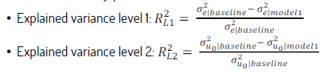Step 3: Add level 1 predictors. Eliminate predictors that have non-significant effects. Calculate the proportion of explained variance at levels 1 and 2 through R2.
* Step 4: Add level 2 predictors. Eliminate predictors that have non-significant effects. Calculate the proportion of explained variance at level 2 only. This is because we do not explain any additional variance at level 1 with the addition of level 2 predictors.
* Step 5: Add random slopes. Even if level 1 predictors are not significant and not in the fixed effects, they can still have significant random slopes.
  + Random effects should be added one by one and tested for significance using a deviance test, which is the anova() function in R.
  + Report the covariance/correlation between the random slopes. In R, it does not give covariance, so you have to either report correlation or convert it into covariance.
  + If you add random slopes, you do not calculate R2 for this model.
  + If you have multiple significant random slopes, they should both be put in the final model, which will look like: (1 + job + time | student).
* Step 6: Add the cross-level interaction. So, you add the cross-level interaction for significant random slopes.
  + You take the variable from level 1 that has a significant random slope and interact with variables at level 2.
  + Include level 2 variables in the interaction that were not significant when first adding level 2 predictors.
  + If an interaction is included, always include the main effects. If a main effect is not significant, the interaction still can be, so it should be included in the model.
  + Now, we have to calculate the proportion of explained variance for the random slope.
    - This is done by using the model with random slopes and no interaction as the baseline model. So, you do: (the variance of the random slope in the random slopes model – variance of the random slope in the interaction model) / (the variance of the random slope in the random slopes model).
* *Why do we need a multilevel model?*
  + This is because observations in the same cluster are generally not independent. These observations tend to be more similar than observations from different clusters. Standard statistical tests are not at all robust against violation of the independence assumption, leading to unreliable estimates.
* *Interpretation of the ICC:*
  + It is the expected correlation between two randomly sampled individuals in the same cluster.
  + It is the percentage of variance at the cluster level.

**Longitudinal Multilevel Models**

* *Steps in Model Building:*
* Step 1: Create the null model, which ignores the multilevel structure. This is just the intercept, but it is not random.
* Step 2: Create the intercept-only model, which is a model with only the random intercepts. This model is used for calculating the ICC even in longitudinal data.
  + In order to test if the level 2 variance is significant, conduct a deviance test, which is the anova() function in R, between the null model and the intercept only model.
* Step 3: Create the intercept only model, but with time as a predictor. This model serves as the baseline model for calculating R2 values.
* Step 4: Add level 1 predictors. Remove level 1 predictors that are not significant.
  + Calculate R2 values for level 1 and level 2.
* Step 5: Add level 2 predictors. Remove level 2 predictors that are not significant. Calculate the R2 for level 2 only.
* Step 6: Allow for random time-effect. We add the random slope for time. Then check if other level 1 predictors have random slopes.
  + This model will serve as the baseline model for calculating the R2 interaction.
* Step 7: Add the interaction effect between the significant random slope variable and level 2 predictors.
  + Now, we have to calculate the proportion of explained variance for the random slope.
    - This is done by using the model with random slopes and no interaction as the baseline model. So, you do: (the variance of the random slope in the random slopes model – variance of the random slope in the interaction model) / (the variance of the random slope in the random slopes model).
* *Interpretation of the ICC:*
  + The expected correlation between 2 randomly sampled occasions within an individual.
  + The proportion of variance in the dependent variable that is between occasions (with individuals).
* *Centering****:***
  + Do not center the outcome variable.
  + You can center both level 1 and level 2 predictor variables.
  + Only center if it makes sense to. For example, if the scale does not include 0.
  + If we center a variable, we make sure 0 corresponds to a meaningful point, hence the intercept variance has a meaningful interpretation.
* *Contextual Effects*:
  + Sometimes the within-cluster effects do not distribute evenly around a common slope. The within effect differs from the between effect.
  + In this case, contextual analysis is preferred.
  + By running a model with a grand mean centered level 1 predictor and an aggregated level 2 predictor based off of this level 1 predictor, we can see how much the between effect still differs while controlling for the within effect.
  + If this regression coefficient of this aggregated 2nd level predictor is significant, this means we need to do a contextual analysis because there is a significant between effect.
  + In order to do this, you need to run a model with cluster mean centered variables and the aggregated level 2 predictor. This will now give us the pure between and within effects.
  + This is because the cluster mean centered variable is orthogonal with the grand mean centered variable.
  + The regression coefficient belonging to the aggregated variable (the level 2 variable based off the level 1 variable) is the contextual effect.

**Multilevel Analysis with Dichotomous and Ordinal Data**

* *Steps in Model Building:*
* *Note: Since it cannot be properly done in R, we will not be coding a model ignoring the multilevel structure.
* Step 1: Create the intercept only model. This is the model with a random intercept and no predictors.
  + This is the model used for calculating the ICC.
  + This model is not used as a baseline for calculating the R2 later on.
* Step 2: Set up a model with the random intercept and the level 1 predictors. Remove non-significant level 1 predictors.
  + Using this model, you can now calculate the variance of the linear predictor using the regression equation. You will use this to calculate the explained variance of the fixed part of the model.
  + You can now also calculate the unexplained variance at level 1 and the unexplained variance at level 2.
  + *Note: The variance at level 1 is always 3.29.
  + 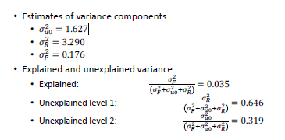An example is below:
* Step 3: Create a model that adds level 2 predictors. Remove non-significant level 2 predictors.
  + Calculate the explained and unexplained variances again using the same process as the previous step.
  + So, we must calculate the variance of the linear predictor using the fixed part of the regression equation.
  + Then, we can calculate the explained and unexplained variances.
* Step 4: Now, we add random slopes to the model.
  + In order to assess whether or not the random slopes are significant, you can use a deviance test, which is the anova() function in R.
  + If the random slopes are significant, we can explain them with a cross-level interaction effect. However, we did not do this in class or in the lab, so it may not come up.
* *Interpretation of the ICC:*
  + It is the expected correlation between two randomly sampled individuals in the same cluster.
  + It is the percentage of variance at the cluster level.
* *Odds Ratios:*
  + You can calculate odds ratios by exponentiating the regression coefficients. In R, this looks like: exp(regression coefficient).
* *Additive and Multiplicative Effects*
  + Regression coefficients provided by the model on the logit are additive.
  + Odds ratios are multiplicative.

**General Notes**

* *Adding Variance Components to Models:*
  + When adding variance components, meaning random intercepts and random slopes, are added to a model, when conducting a deviance test (the anova() function in R), we must divide the p-value by 2.
  + So, this first occurs when you the random intercept to the model ignoring the multilevel structure. When you compare these models, which are typically M1 and M0, you must divide the p-value of the chi-square by 2.
  + This also occurs when you add random slopes to the model. When you compare the model, you have added random slopes into to the previous model which does not have random slopes using the anova() function, you must divide the chi-square p-value by 2.
* *Predictive Intervals Versus Confidence Intervals*
  + We calculate predictive intervals in the model building process when we add random slopes.
  + **Predictive intervals** are calculated by taking the point estimate (regression coefficient) +/- 1.96*SD of the random effect. You will have to take the square root of the variance in order to get the standard deviation.
    - Interpretation: 95% of the regression coefficients of the predictor will fall between the interval [x, y].
  + **Confidence intervals** are calculated by taking the point estimate (regression coefficient) +/- 1.96*SE of the fixed effect.
    - Interpretation: If repeated samples were taken and the 95% confidence interval computed for each sample, 95% of the intervals would contain the population mean.
* 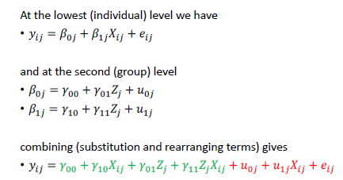*Example Equations from MLM lectures:*
  + For normal multilevel analysis, we have:
  + 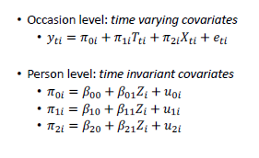For longitudinal multilevel analysis, we have:
    - 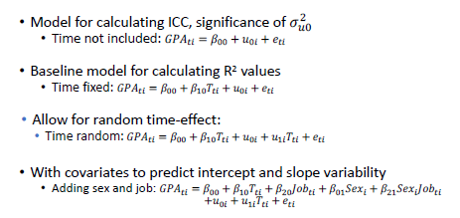Another example for longitudinal:
  + 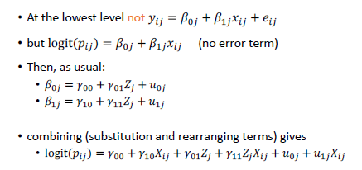For multilevel analysis with a dichotomous outcome:
* *ICC in Three-Level Models:*
  + 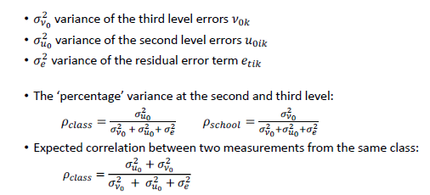Slide summary:
  + The ICC can be interpreted in two ways:
    - If we interpret as the percentage of variance at some level, for all levels we calculate by taking the variance at that level and dividing by the total variance.
    - If we interpret as the expected correlation for the second level, we need to add the variance of the third level in the numerator. This is because the second level components are nested in the third level.
    - These two points can be seen in the slide above.
* *Note on Degrees of Freedom:*
  + *Note: The degrees of freedom for the deviance test in R is the difference between the number of parameters in the two models. So, if model 1 is 7 and model 2 is 9, then the df is 2.